| **Test Name** | | Search for Worker in System | | | |
| --- | --- | --- | --- | --- | --- |
| **Use Case Tested:** | | Use Case 9 – Manage Worker | | | |
| **Test Description:** | | User needs to search for a worker  User navigates to Search Workers tab.  User is presented with a list of workers.  User enters varies search criteria | | | |
| **Pre-conditions** | | Workers must exist in the system | | | |
| **Post-conditions** | | The database successfully updates list for workers matching search criteria  The database returns a message if search criteria is not matched | | | |
| **Notes:** | |  | | | |
| **Result (Pass/Fail/Warning/Incomplete)** | |  | | | |
|  | **TEST STEP** | | **EXPECTED TEST RESULTS** | P | F |
|  | User selects “Search Workers” from the menu bar | | A list of workers appears | X |  |
|  | User enters a search on the Worker Id | | A list of workers containing search criteria appears | X |  |
|  | User enters a search on the First Name | | A list of workers containing search criteria appears | X |  |
|  | User enters a search on the Surname | | A list of workers containing search criteria appears | X |  |
|  | User enters a search on the Role | | A list of workers containing search criteria appears | X |  |
|  | User enters a search on a non-existing Worker Id | | Message appears that the record was successfully added | X |  |
|  | User enters a search that may be in found in First Name, Surname, or Role | | A list of workers containing search criteria appears | X |  |

|  |  |  |  |  |  |
| --- | --- | --- | --- | --- | --- |
| **Test Data Table** | | | | | |
|  | **1** | **2** | **3** | **4** | **5** |
| Test | 34 | an | ye | tr | har |
| Non-existing Id | 99 |  |  |  |  |
|  |  |  |  |  |  |
|  |  |  |  |  |  |

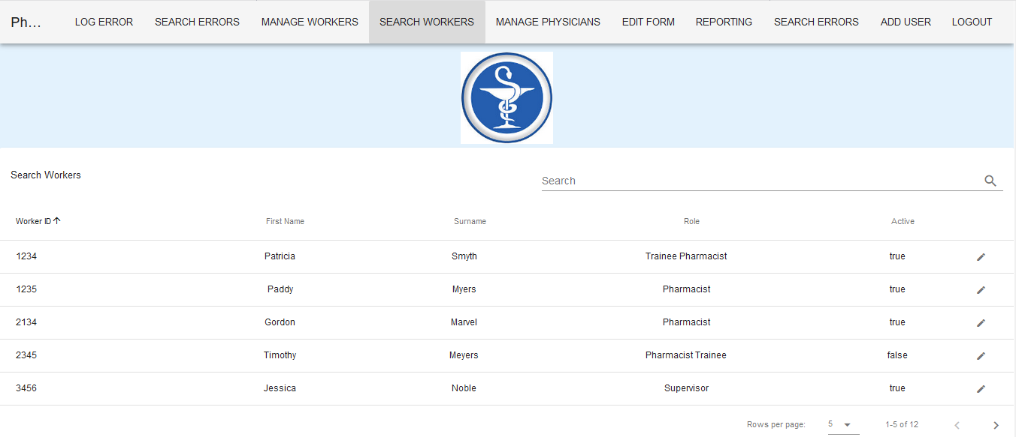

List of workers appears on selection of Search Workers Tab – 12 records available in the database

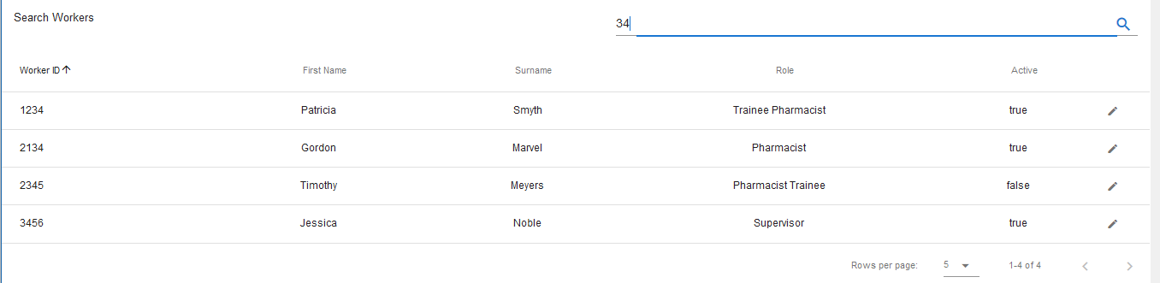

Search results returning records containing ‘34’

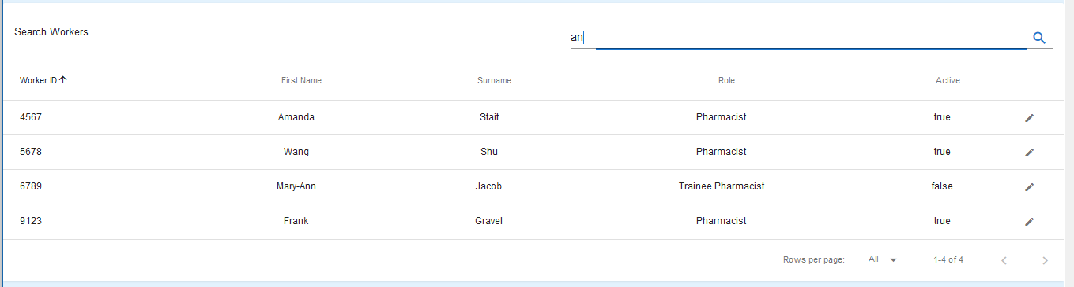

Search results returning records containing ‘an’

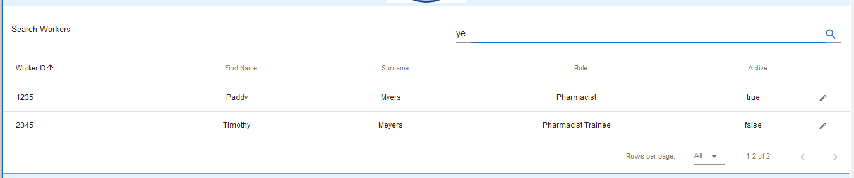

Search results returning records containing ‘ye’

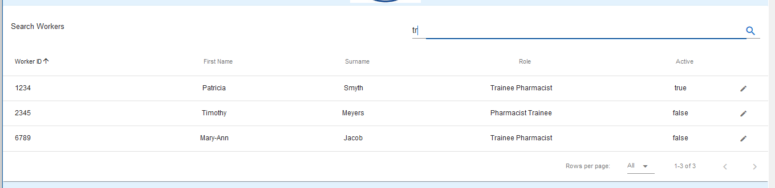

Search results returning records containing ‘tr’

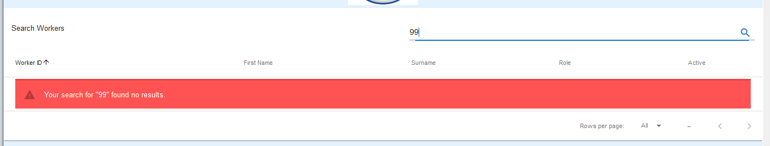

Search results returning records containing ‘99’

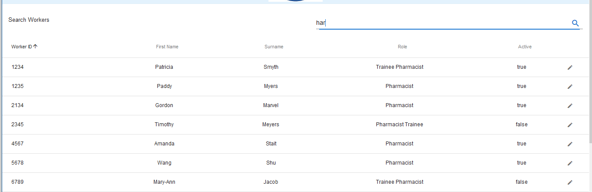 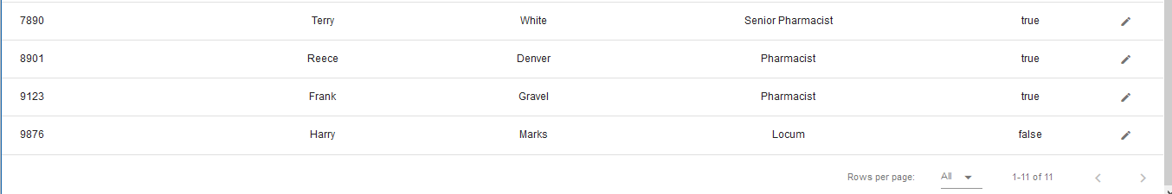

Entering ‘har’ returned 11 of the 12 worker records in the database. Harry Marks appears as ‘har’ is in his first name.